

Assignment 1 CSCI 3070

Asymptotic Notations, Divide and Conquer, Heap



October 11, 2020

OTU

Andrew Murdoch

100707816

Assignment 1

Part 1:

a) T(n) = 2T(n/2) + 3n + 7 (Master Theorem)

a = 2 b = 2 $\log_{2}{2=1 }K=1$

Since both $\log_{2}{2 and K are equal }$ and p = 0, case 2 of master theorem applies.

Therefor T ∈ $Θ(n \log{n)}$.

b) T(n) = 7T(n/2) + $n^{2}$ (Recursion Tree)

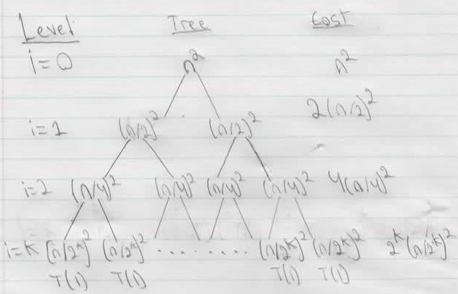

= = = =

1

= = = = = = O(n2)

c) T(n) = T(n/2) + T(n/4) + T(n/8) + n (Substitution method with guess of O (n log n))

T(n) = $c(\left(\frac{n}{2}\right)\lg\left(\frac{n}{2}\right)+\left(\frac{n}{4}\right)\lg\left(\frac{n}{4}\right)+\left(\frac{n}{8}\right)\lg\left(\frac{n}{8}\right))$

T(n) = $c(\left(\frac{n}{2}\right)(lg{n}-\lg{2})+\left(\frac{n}{4}\right)(lg{n}-\lg{4})+\left(\frac{n}{8}\right)(lg{n-\lg{8)}})$

T(n) = $c(\left(\frac{n}{2}\right)(lg{n}-1)+\left(\frac{n}{4}\right)(lg{n}-2)+\left(\frac{n}{8}\right)(lg{n-3})$)

T(n) = $c(\frac{n}{2logn}-\frac{n}{2}+\frac{n}{4\log{n}}-\frac{n}{2}+\frac{n}{8\lg{n}}-\frac{3n}{8}$)

T(n) = $cn(\frac{1}{2logn}-\frac{1}{2}+\frac{1}{4\log{n}}-\frac{1}{2}+\frac{1}{8\lg{n}}-\frac{3}{8}$)

T(n) = $cn(\frac{1}{2logn}+\frac{1}{4\log{n}}+\frac{1}{8\lg{n}}-\frac{11}{8}$)

T(n) = $c(\frac{7}{8n(\log{n)}}-\frac{11}{8n}$) “n log n grows faster than n”

Therefor T(n) = O(n log n)

d) T(n) = 4T(n/16) + $\sqrt{n}$ (Master Theorem)

a = 4 b = 16 $\log_{16}{4}{=1/2 }K=1/2$

Since both $\log_{2}{2 and K are equal }$ and p = 0, case 2 of master theorem applies.

Therefor T ∈ $Θ(\sqrt{n} \log{n)}$.

Part 2:

|  |  |
| --- | --- |
| Category | Functions |
| Constant |  |
| Linear | $2^{\log_{2}{n}}$, 18n |
| Polynomial | n2, 3n2 +7n+15, , n3 -log n , n3 , |
| Exponential | 2n, 4n, n71+5n +17n |
| Factorial | n! |
| Logarithmic | $\log_{10}{n}$, ${3log}_{2}{n}$, |